ASSIGNMENT TESTING

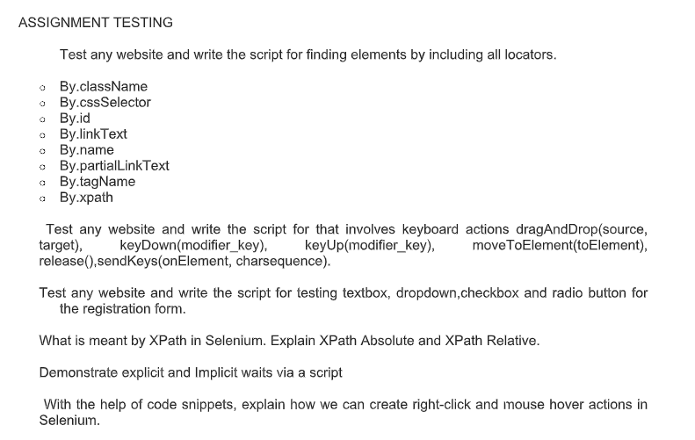

Solution with Locators

By.className

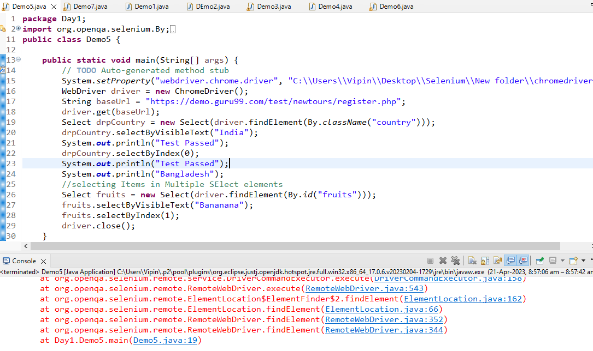

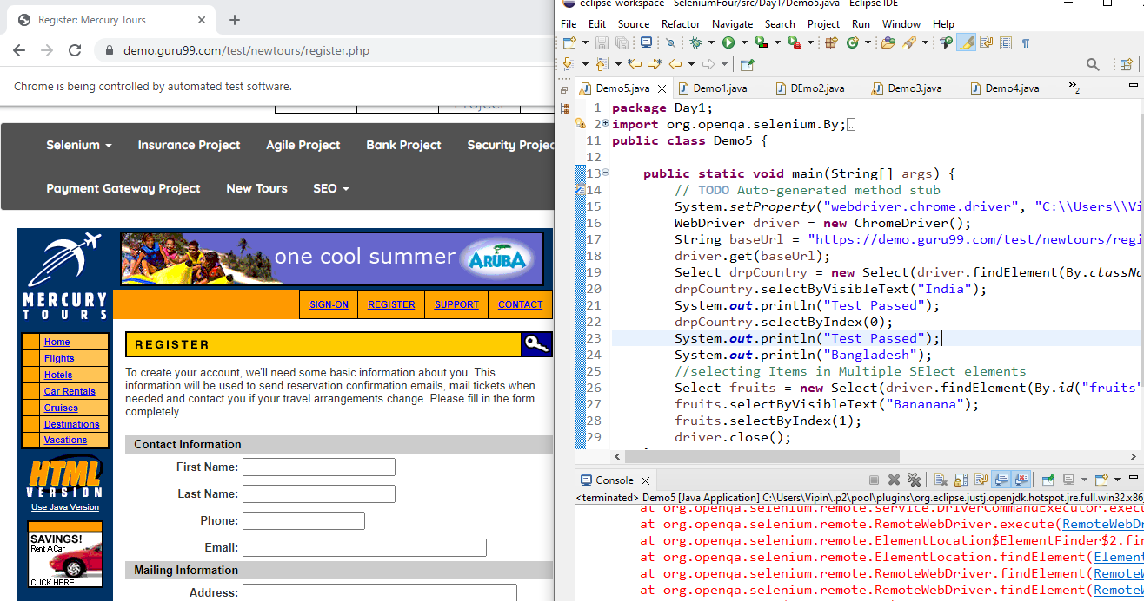

By.id

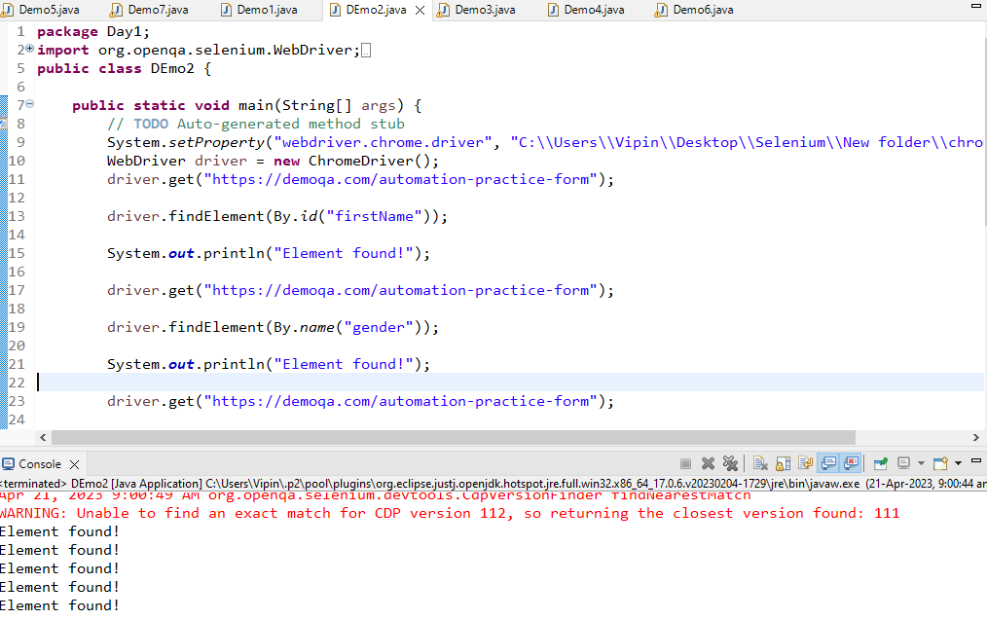

By.name

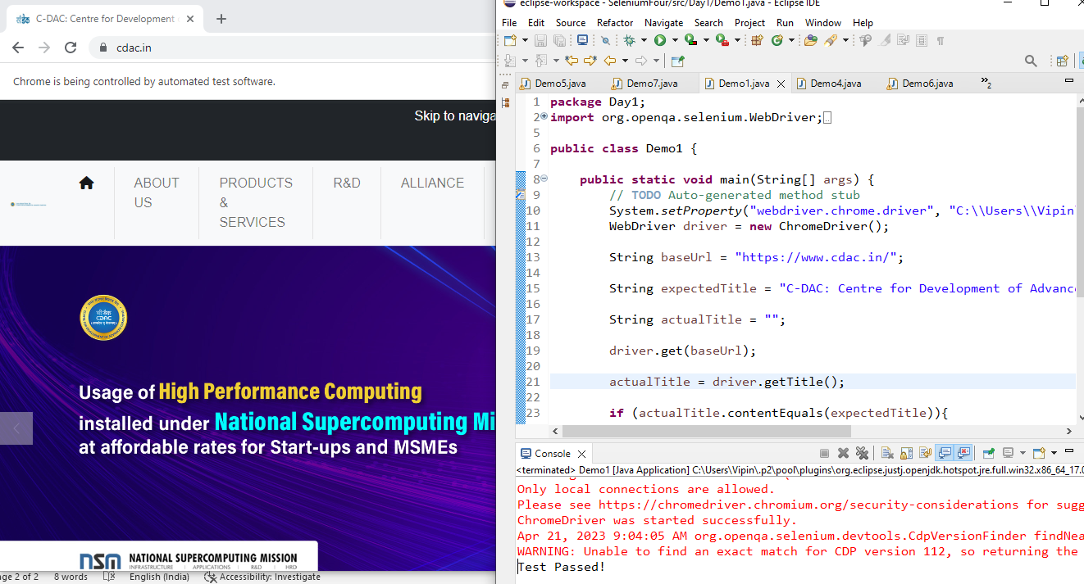

By.xpath

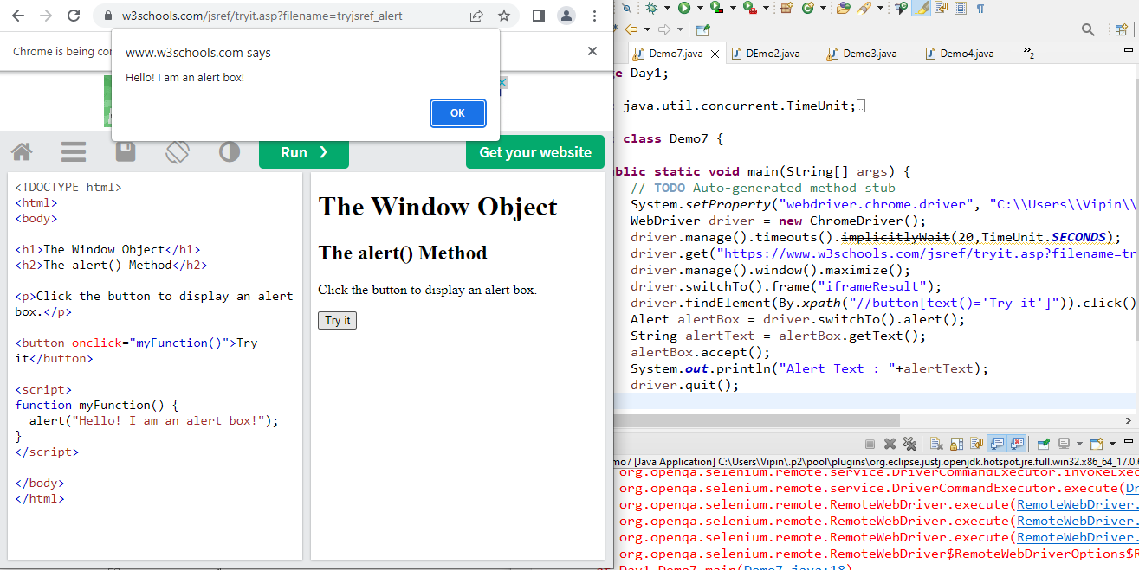

Test any website and write the script for that involves keyboard actions dragAndDrop (source,target), keyDown(modifier_key), keyUp(modifier_key), moveToElement(toElement),

release(),sendKeys(onElement, charsequence).

Solution